**Business Process Improvements – SAP implementation at Volvo Poland Industry (Bus Plant)**

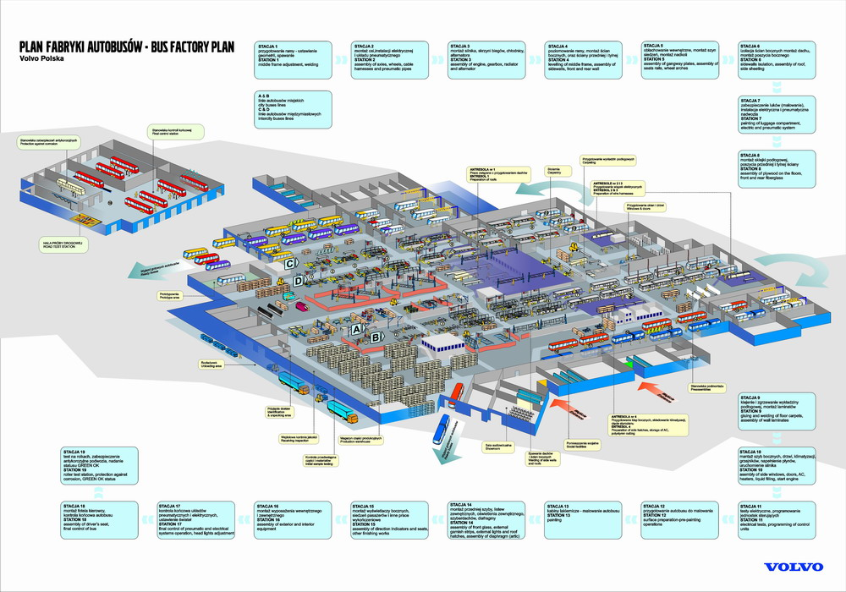

**Objectives:**

* To familiarize students with the basic tools and techniques of project management
* To get initial understanding of Production Processes in Bus Plant
* To gather practical experience of how to manage the project as an example of simulation game
* To learn how to work in the project team and getting to know the typical roles in the project

**Assumptions:**

* Maximally up to 8 teams, each team consists of 4
* Total available time to complete is limited to 90 minutes. As every project the timeline is very aggressive, so it is important to share/delegate activities
* At least one PC with MS Excel is to be provided per Project Team

**Preamble**

Volvo Poland Industry is a part of Volvo Bus Corporation offering complete vehicles, chassis, bodies, solutions for urban transport systems.

The Wroclaw factory is the largest Volvo buses in Europe, where manufacturing of city, intercity and tourist buses is executed. Vehicles from the Wroclaw factory are supplied to markets throughout Europe, and their customers are public transport companies, carriers on the route intercity and international travel agencies.

Volvo provides customers with vehicles combining advanced technology with the highest standards of quality and safety. The company also pays great importance to environmental concerns. Since 2010 the Wroclaw factory produced hybrid buses, which, thanks to significant reductions in emissions and fuel consumption, meet the highest environmental standards.

Wroclaw plant is involved in entire supply chain of products ranging from design to construction, adaptation to customers, through manufacturing, to business units and support after the sale.

**Project background**

Volvo Poland Industry plans to increase Production capacity from 1000 to 2000 bus units per year. In order to make it happen the company decided to launch Business Process Improvements project, which will be supported by SAP implementation. Steering Committee has been appointed and you and your team have been selected to manage this critical initiative.

**Bus Plant Process Map**

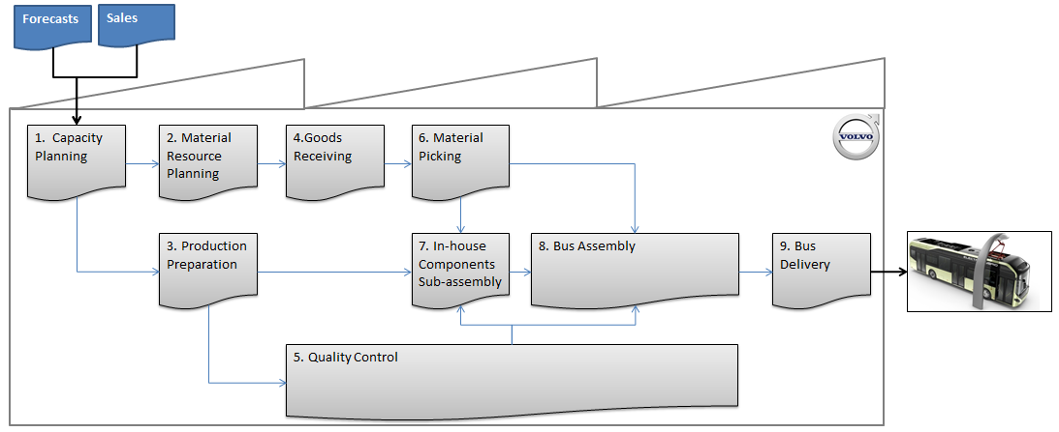

**Current Process Production Cycle per 1 Bus Unit**

|  |  |  |  |  |
| --- | --- | --- | --- | --- |
| **ID** | **Activity** | **Duration (h)** | **FTE** | **Worktype** |
| 1 | Capacity Planning | 2 | 2 | White collar |
| 2 | Material Resource Planning | 4 | 4 | White collar |
| 3 | Production Preparation | 6 | 4 | White collar |
| 4 | Goods Receving | 10 | 5 | Blue collar |
| 5 | Quality Control | 4 | 4 | White collar |
| 6 | Materials Picking | 2 | 8 | Blue collar |
| 7 | In-house Component Sub-assembly | 20 | 8 | Blue collar |
| 8 | Bus Assembly | 16 | 48 | Blue collar |
| 9 | Bus Delivery | 2 | 4 | White collar |

Additionally estimated costs of the workload are following:

* White collar – 200 PLN/h
* Blue collar – 50 PLN/h

**Identified Requirements, Development & Value Added**

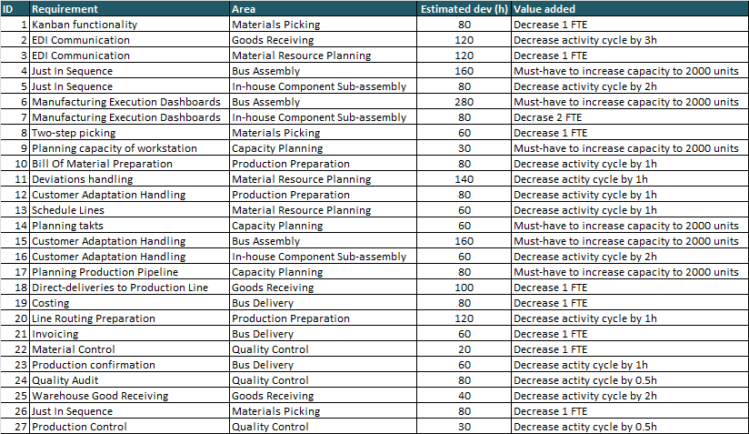

It is important to highlight that Solution Architect provided only estimated development. Based on analogical estimation here comes the estimation pattern for project split by phases:

|  |  |  |
| --- | --- | --- |
| **Waterfall deployment (Phased)** | | **Estimate benchmark** |
| Plan | | 10% |
| Analyze | | 15% |
| Design | | 15% |
| Build (Development) | | 30% |
| Test | | 20% |
| Deploy | | 10% |
|  |  | 100% |

Example:

If Development is estimated for 24 hours, Plan and Deployment will take 8 hours each, while Analyze and Design will consume 16 hours each and finally Test: 16 hours, which make a total of 80 hours as a work package.

**Activity 1 – Calculate Business Case**

Taking into account that Average Weighted Cost of Project Team is 300 PLN please calculate project business case as payback period. In order to arrive at final value please calculate:

1. Project costs
2. Project added value (cost savings by new production volume)

The **payback period** is calculated by counting the number of periods it will take to recover the cash invested in a project (yearly or monthly or daily)

**Activity 2 – Manage Project Scope**

Steering Committee informed you that project budget has been reduced to 2M PLN due to economy downturn. For the budget calculation still use Average Weighted Cost of Project Team is 300 PLN.

Additionally your Solution Architect highlighted that certain requirements touches more than one Business Process meaning that they can be either fully implemented or rejected completely e.g. Just-In-Sequence cannot be implemented partially only for one Area.

Moreover two critical processes as Quality Control and Bus Delivery today are not supported by any IT tool and it is a must to implement system to execute Business processes. Additionally it turned that EDI technology cannot be implemented.

Your task is to reduce the project scope by setting following priories:

* Must-Have requirements are Priority 1 Requirements
* All others have to be evaluated in terms of their value added vs. implementation cost. You need to fit to the budget.
* Out-of-scope requirements (due to technology or budget feasibility)

**Activity 3 – Project Team & Tasks Delegation**

According to the scope of the project some key IT resources need to be secured in order to execute all phases of the project smoothly and build a reliable time plan.

For this scale of the project it is essential to build IT team consisting of following IT roles covering all areas of the project (for the easiness of calculation it is assumed that one role is covering the effort of one phase, which does not happen in the real projects and next activities):

|  |  |
| --- | --- |
| **Lead IT role** | **Main engagement in** |
| Project Manager (PM) | Plan |
| Business analyst (BA) | Analyze |
| Solution Architect (SA) | Design |
| Developer (D) | Develop and Deploy |
| Tester (T) | Test |

Your task is to:

1. Estimate the IT effort in working hours needed to deliver all business requirements. Consider all IT roles in the project and % engagement of each role. Assume that finally agreed development is 1980 hours and we use analogical benchmarks to arrive at effort per phase
2. Request IT resources to fit in proposed time plan. Assume there is one Project Manager for the project. You have to request a proper number of business analysts, solution architects, testers and developers (Full time equivalents). Point out your team.

Waterfall phases duration:

**Activity 4 – Project Schedule**

Right now we have finished Plan phase. As a project manager one of your tasks is to create realistic project schedule. The initial Design Phase plan has been created:

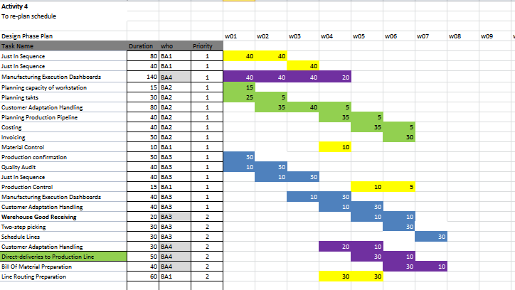

The plan is not finished yet you have plan vacations of 2 weeks length in W05-06 for all people in the team.

After a week of the phase started you have learned that:

1. One Business Analyst (BA2) went on a sick leave for 3 weeks, starting W02. You have to re-plan your schedule accordingly. There is no replacement for him found in the organization.
2. Just in Sequence tasks has been re-estimated by BA and will need additional 50% of time.

Having the initial plan – please re-schedule the Design phase.

1. State for how long (in weeks) this phase should be planned.
2. How the total schedule will be impacted?
3. What else should you consider during planning? Is it possible to shorten the schedule – how? What can be the consequences?

**Activity 5 – Project Budget**

Project budget has been established using following details:

* **Price List for Volvo IT Roles for 2016**

|  |  |  |
| --- | --- | --- |
| **Role** | **Rate [PLN/h]** | **Location** |
| Project/Test Manager (PM) | 300 | PL |
| Business Analyst (BA) | 200 | PL |
| Solution Architect (SA) | 300 | PL |
| Developer (D) | 250 | PL |
| Tester (T) | 200 | PL |
| Solution Architect (SA) | 700 | FR |

* **Assuming all project resources are located in Poland for the time being**

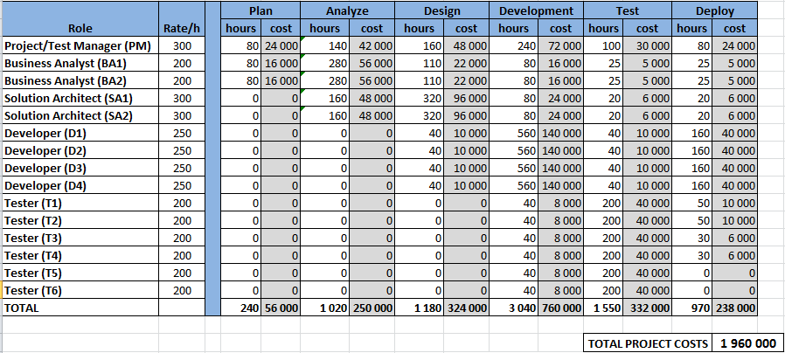

* **Current involvement of roles per week during Analysis Phase is: Project Manager-20h, Solution Architect-40h, Business Analyst-40h**

During Analysis phase a lot of disturbances have been encountered. Discussions with business stakeholders are very difficult and it is hard to have final agreement regarding solution within preliminary assumed time. During discussion with team Project Manager received recommendation from business analysts to prolong Analysis phase for 4 weeks (involvement of all team members will stay the same as during Analysis Phase).

It also appears that one of Solution Architect planned to be involved in the project is sick and will not be able to take part in the project. After seeking of replacement of this team member within organization it is identified that the only solution architect with appropriate skills level is available in another site (France) what may affect budget due to higher rate per h.

What will be the new cost of analysis phase after prolongation, including new solution architect appointment? How will change total cost of project?

**Activity 6 – Manage Project Risks**

The business environment is very dynamic. There are a lot of organizational changes in VPI, which may lead to Steering Committee changes. It is very likely that SC Chairman leaves the company soon. There are also other critical projects and initiatives that are very possible to be prioritized soon and that includes SAP technical upgrade project, which may cause that SAP implementation in VPI is postponed to the next year (until the technical upgrade is ready, no point to implement old version of SAP now).

The project performance is also influenced due to the fact that Project Manager is not experienced in SAP implementations as well as Solution Architect takes part in several other initiatives and is not fully dedicated to this project itself. This cause medium impact on project activities and the probability of this negative influence is also medium in both cases (PM and Solution Architect).

Project resources required for solution development are located in Poland and the project budget for build phase is calculated according to Polish rates. However it is probable that development team in India can be involved and take over tasks from Polish team (currently colleagues in India are fully booked but it is possible that their workload is reduced soon), which may cause that total cost of development is reduced by 40%. This is a good opportunity for savings in project budget.

Your task is to identify at least five project risks/project opportunities and analyze them according to the below pattern:

* list the risks/opportunities
* evaluate probability and severity
* prioritize the risks/opportunities

Propose a risk owner and a risk response for the most critical risks (high priority).

Use the table provided in the excel file.

**Activity 7 – Manage Project issues (not included in initial hand-out)**

* **Issue #1 (after 45 min)**

Project Manager is sick. He is unable to drive project activities for some time (5 minutes). He needs to delegate his tasks (30 seconds).

PM Governance team points out person who will pretend sickness.

* **Issue #2 (after 60 min)**

VPI Management considers reprioritizing the projects and there is a risk that SAP implementation is stopped or postponed. Project Manager organizes a meeting to present why and how important is his project.

PM Governance team points out person who will prepare short presentation (2 minutes to present 3 reasons to continue the project).

* **Issue #3 (after 75 min)**

Development team will be sourced from India. This will reduce total cost of build phase by 40%. Recalculate the project budget (still use average weighted cost as blended rate) and decide on how to manage the savings.

**Activity 8 – Manage Lessons Learned**

* **Lessons Learned**

Business Process Improvements project, based on SAP implementation is now over. Good practice at the end of every project is to create a project final report, which should be prepared by Project Manager and presented to Steering Committee. The goal of this activity is to go through all previous project activities and conclude this simulation game.

Please analyze project results and prepare lessons learned from this project based on following information:

* Results achieved
* Results not achieved
* Positive experiences
* Negative experiences
* Lessons learned (in order to avoid done mistakes)

Take a look at the VBC Plant Case Study objectives, written at the beginning of this document and try to explain what you learnt from this case study.